HOMEWORK 5
Based on the SQL script file for Pine Valley Furniture Company, write the SQL statements
for the following queries
1. What are the names of all customers who have placed orders?
Query: SELECT DISTINCT CUSTOMER_NAME, COUNT(ORDER_ID) AS 'NUMBER OF ORDERS'
FROM S_CUSTOMER_T, S_ORDER_T
WHERE S_CUSTOMER_T.CUSTOMER_ID = S_ORDER_T.CUSTOMER_ID
GROUP BY CUSTOMER_NAME;
Screenshot:
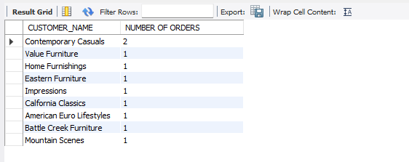
2. What are the product descriptions ordered by the customer ID, 1?
Query: SELECT S_CUSTOMER_T.CUSTOMER_ID, PRODUCT_DESCRIPTION
FROM S_CUSTOMER_T, S_ORDER_T, S_ORDER_LINE_T, S_PRODUCT_T
WHERE S_CUSTOMER_T.CUSTOMER_ID = S_ORDER_T.CUSTOMER_ID
AND S_ORDER_T.ORDER_ID = S_ORDER_LINE_T.ORDER_ID
AND S_ORDER_LINE_T.PRODUCT_ID = S_PRODUCT_T.PRODUCT_ID
AND S_CUSTOMER_T.CUSTOMER_ID =1;
Screenshot:
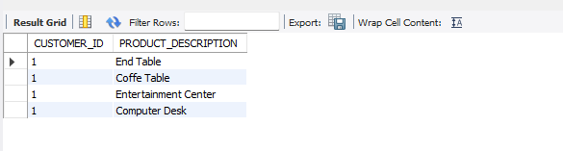

3. What are the product descriptions ordered by the customer, ‘Impressions’?
Query: SELECT CUSTOMER_NAME, PRODUCT_DESCRIPTION
FROM S_CUSTOMER_T, S_ORDER_T, S_ORDER_LINE_T, S_PRODUCT_T
WHERE S_CUSTOMER_T.CUSTOMER_ID = S_ORDER_T.CUSTOMER_ID
AND S_ORDER_T.ORDER_ID = S_ORDER_LINE_T.ORDER_ID
AND S_ORDER_LINE_T.PRODUCT_ID = S_PRODUCT_T.PRODUCT_ID
AND CUSTOMER_NAME = 'Impressions';
Screenshot:
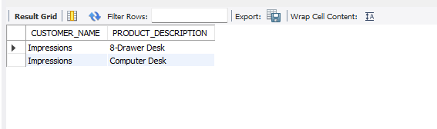
4. List all customers’ names that have placed an order that contains a product whose standard price is over 500.
Query: SELECT CUSTOMER_NAME, PRODUCT_DESCRIPTION, STANDARD_PRICE
FROM S_CUSTOMER_T, S_ORDER_T, S_ORDER_LINE_T, S_PRODUCT_T
WHERE S_CUSTOMER_T.CUSTOMER_ID = S_ORDER_T.CUSTOMER_ID
AND S_ORDER_T.ORDER_ID = S_ORDER_LINE_T.ORDER_ID
AND S_ORDER_LINE_T.PRODUCT_ID = S_PRODUCT_T.PRODUCT_ID
AND STANDARD_PRICE > 500;
Screenshot:
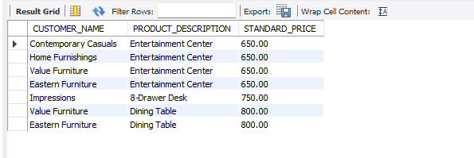

5. List all customers. Print the order ID (s) along the customer information if they have submitted the order(s).
Query: SELECT O.ORDER_ID, C.*
FROM S_CUSTOMER_T C LEFT JOIN S_ORDER_T O
ON C.CUSTOMER_ID = O.CUSTOMER_ID
WHERE O.ORDER_ID IS NOT NULL;
Screenshot:
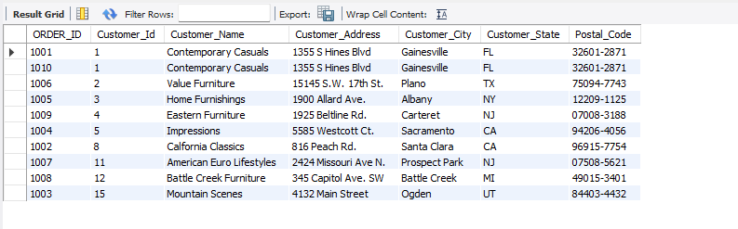
6. Display the subtotal amount of each orderline in each order
Query: SELECT ORDER_ID, ORDERED_QUANTITY, STANDARD_PRICE, ORDERED_QUANTITY*STANDARD_PRICE AS SUBTOTAL_PRICE
FROM S_ORDER_LINE_T, S_PRODUCT_T
WHERE S_ORDER_LINE_T.PRODUCT_ID = S_PRODUCT_T.PRODUCT_ID
ORDER BY ORDER_ID
Screenshot:
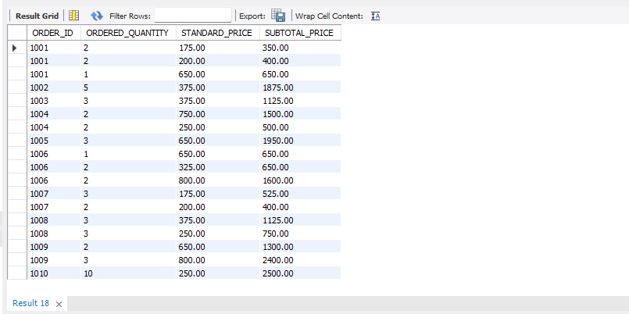
7. Display the total amount of each order.
Query: SELECT S_ORDER_T.ORDER_ID, SUM(S_ORDER_LINE_T.ORDERED_QUANTITY*S_PRODUCT_T.STANDARD_PRICE) AS TOTAL_AMOUNT
FROM S_ORDER_LINE_T, S_PRODUCT_T, S_ORDER_T
WHERE S_ORDER_LINE_T.PRODUCT_ID = S_PRODUCT_T.PRODUCT_ID
AND S_ORDER_LINE_T.ORDER_ID = S_ORDER_T.ORDER_ID
GROUP BY S_ORDER_T.ORDER_ID
Screenshot:
